**SQL**

**Joins:**

The SQL Join clause is used to combine the records from two or more tables in a database. A JOIN is a means for combining fields from two tables by using values common to each.

**SQL JOIN Types:**

* **INNER JOIN:** returns rows when there is a match in both tables.
* **LEFT JOIN:** returns all rows from the left table, even if there are no matches in the right table.
* **RIGHT JOIN:** returns all the rows from the right table, even if there are no matches in the left table.
* **FULL JOIN:** return rows when there is a match in one of the tables.
* **SELF JOIN:** is used to join a table to itself as if the table were two tables, temporarily renaming at least one table in the SQL statement.
* **CARTESIAN JOIN:** return the Cartesian product of the sets of records from the two or more joined tables.

**Triggers:**

Triggers are stored programs, which are automatically executed or fired when some events occur.

**Procedure:**

A stored procedure is nothing more than a prepared SQL code that you save so you can reuse the code over and over again.

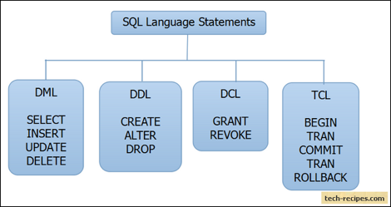

**Index:**

Indexes are special lookup tables that the database search engine can use to speed up data retrieval.

**T-SQL: Deleting all duplicate rows but keeping one [duplicate]**

delete from mfi_update_payments where ASSIGNMENT_NBR=3 and rownum<=(select count(*)-1 from mfi_update_payments where ASSIGNMENT_NBR=3);